**Project Management ESE**

**Prn : 2019BTECS00089**

**Name : Piyush Mhaske**

**Batch: B3**

Que1 : Create a Movie recommendation system project with template as Scrum and add 3 team members into your project.

Adding 3 team members:

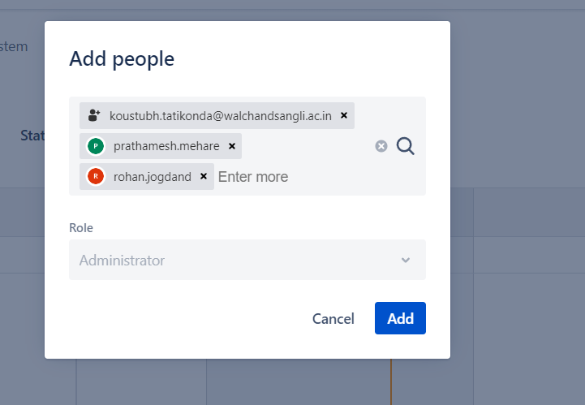

2) Create 3 Epics :

a) Creating web application for User registration:

b)Creating web applications for movie recommendation based on user emotions

c) Creating backend database for storing and fetching required detail

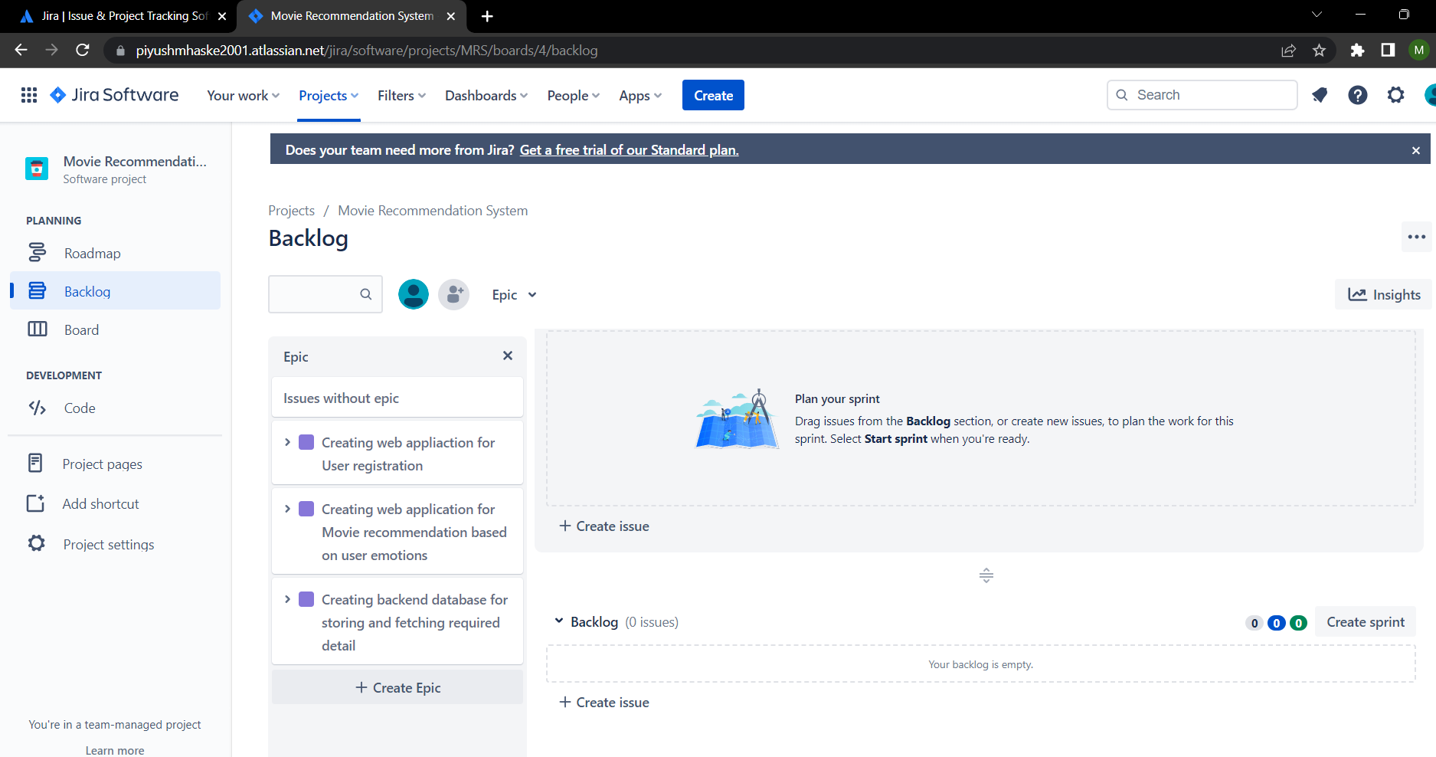

3) Create user stories belonging to every epic

Epic 1:

* User Story 1: User registration form design with all components and event handling

* User Story 2: Testing of application with respective validations

Epic 2:

* User Story 3: Emotion recognition and movie recommender form design with all components and event handling

* User 4: Testing of applications with respective validations

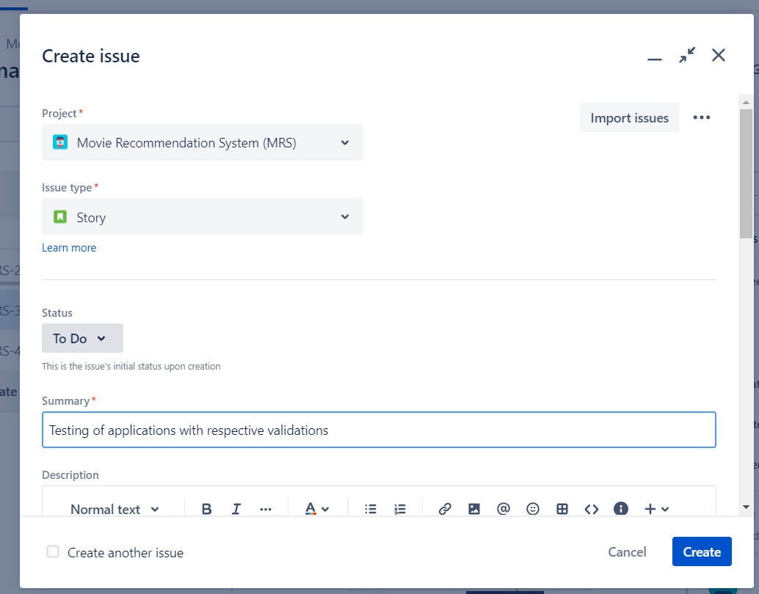

Epic 3:

* User Story 5: Creation of all necessary tables with respective constraints

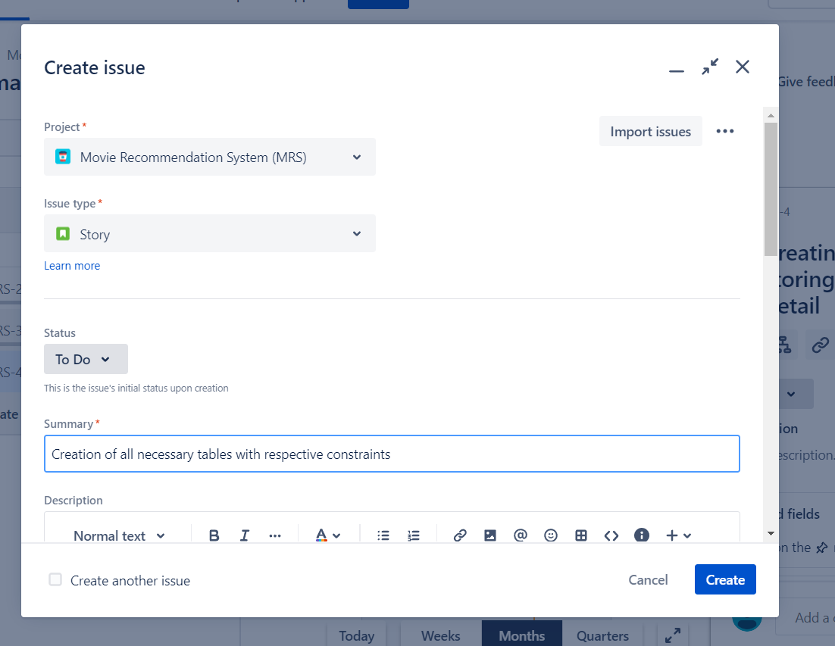

* User Story 6: Checking/ Testing for different data entries

4. Assign each user story to corresponding team members

Assigning task to team members: 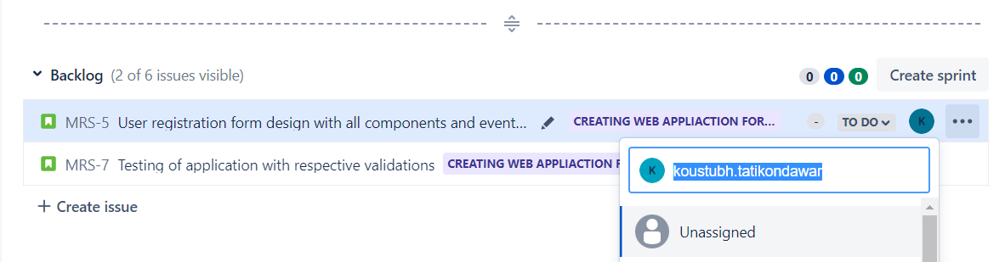

5. Create sprints for every user stories and prioritize them accordance to your tasks. Assign time period for every user story. (For all user stories 1 Week)

Creating Sprints:

Sprint 1:

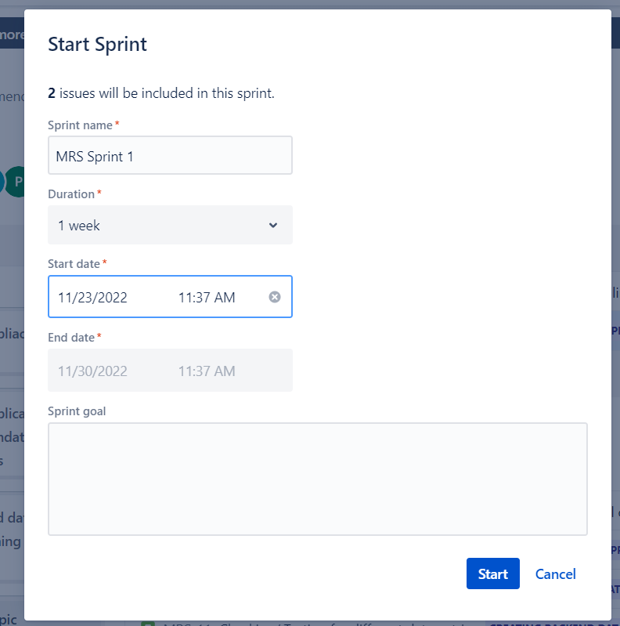

Sprint 2:

Sprint 3:

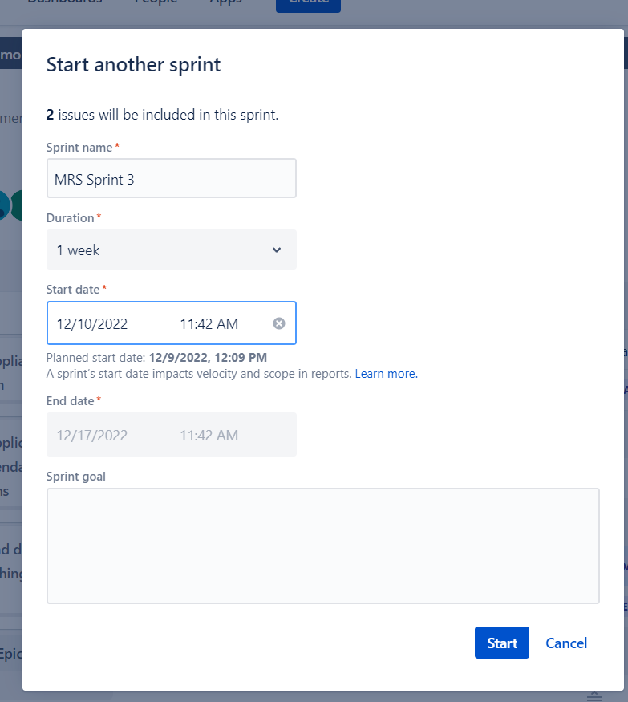

6) Update the status of some user stories as ToDo, In progress or Completed according to sprints (add appropriate comments)

User story 1, 3, and 5 – Inprogress

User Story 2,4 – To Do

User Story 6 - Complete

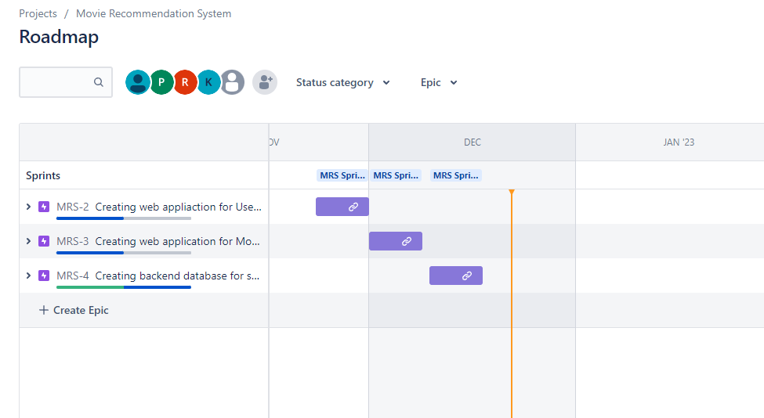

7 ) Create a bug/issue for respective user story and epic and assign to respective member

Bug for :

Epic 1 : user story 1

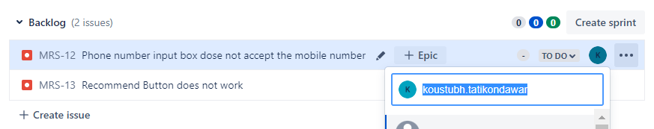

Issue 2 :

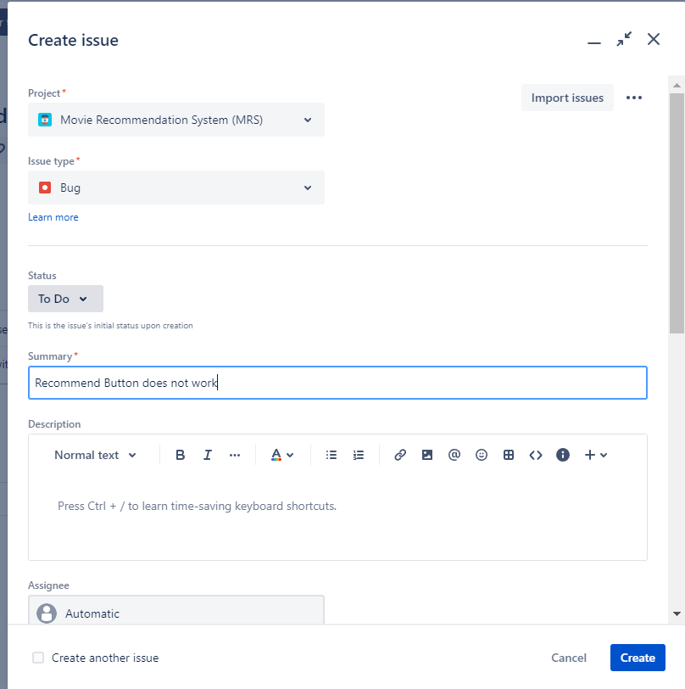

Bug 2: assigned to Piyush

